Roll.no:2303a54008

NAME:Ch.Abhinav

BATCH:47-A

Lab 11 – Data Structures with AI: Implementing Fundamental

Structures

**Lab Objectives**

• Use AI to assist in designing and implementing fundamental data

structures in Python.

• Learn how to prompt AI for structure creation, optimization, and

documentation.

• Improve understanding of Lists, Stacks, Queues, Linked Lists,

Trees, Graphs, and Hash Tables.

• Enhance code quality with AI-generated comments and

performance suggestions.

**Task Description #1 – Stack Implementation**

Task: Use AI to generate a Stack class with push, pop, peek, and is_empty

methods.

Sample Input Code:

class Stack:

pass

Expected Output:

• A functional stack implementation with all required methods and

docstrings.

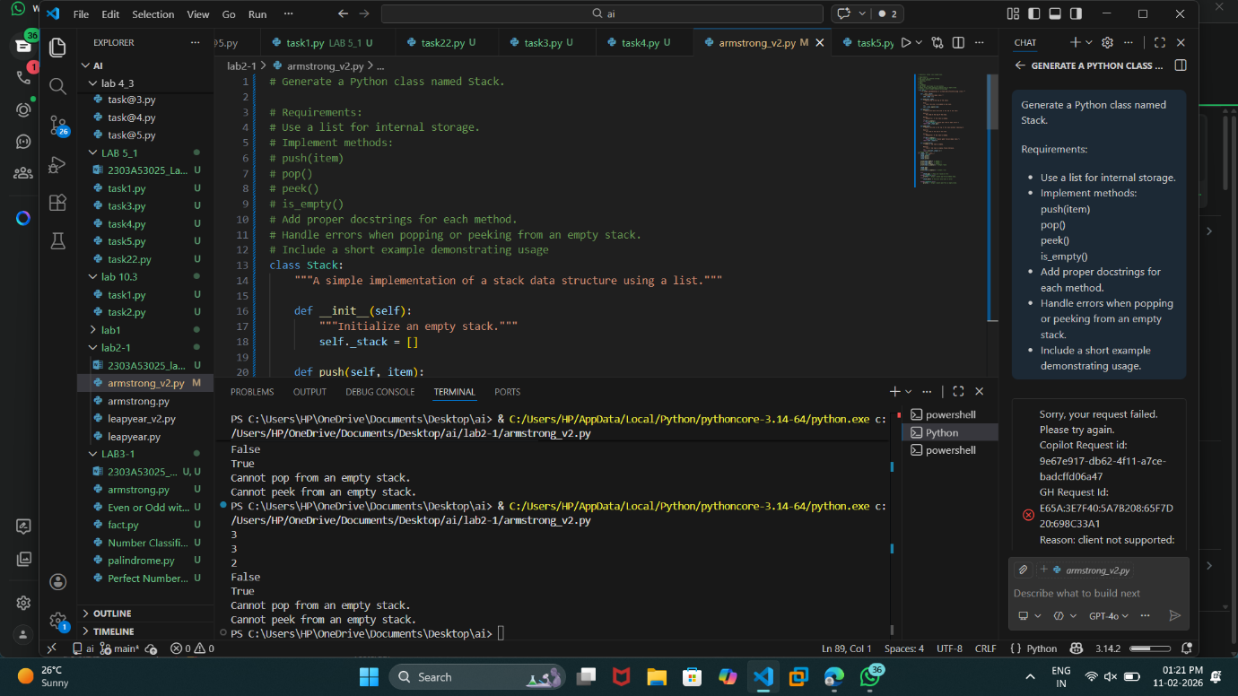

**Task Description #2 – Queue Implementation**

Task: Use AI to implement a Queue using Python lists.

Sample Input Code:

class Queue:

pass

Expected Output:

• FIFO-based queue class with enqueue, dequeue, peek, and size

Methods

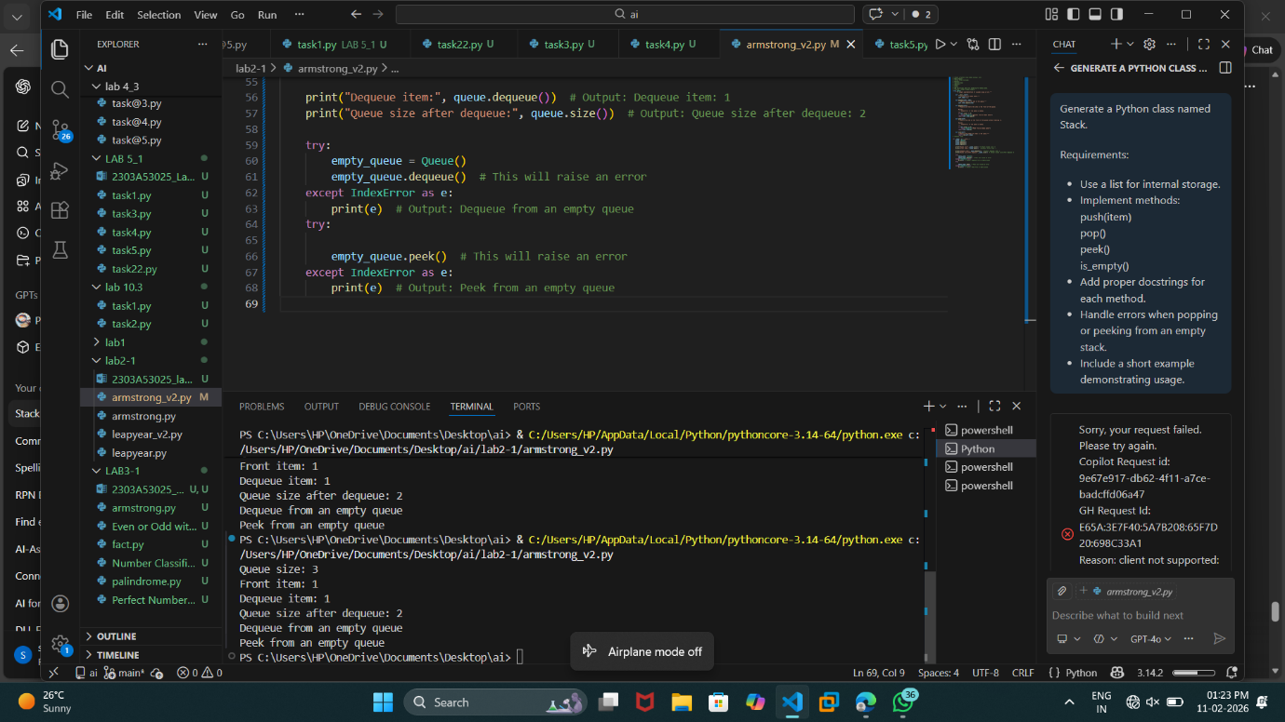

Task Description #3 – Linked List

Task: Use AI to generate a Singly Linked List with insert and display

methods.

Sample Input Code:

class Node:

pass

class LinkedList:

pass

Expected Output:

• A working linked list implementation with clear method

documentation.

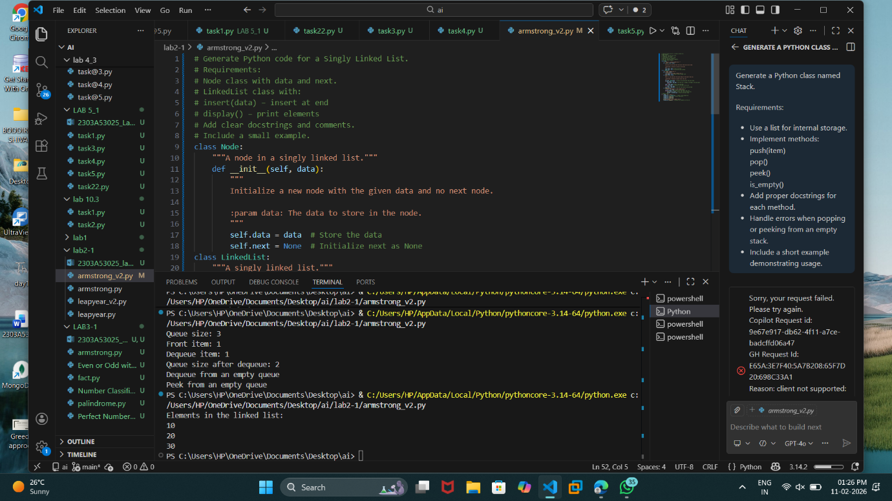

**Task Description #4 – Binary Search Tree (BST)**

Task: Use AI to create a BST with insert and in-order traversal methods.

Sample Input Code:

class BST:

pass

Expected Output:

• BST implementation with recursive insert and traversal method

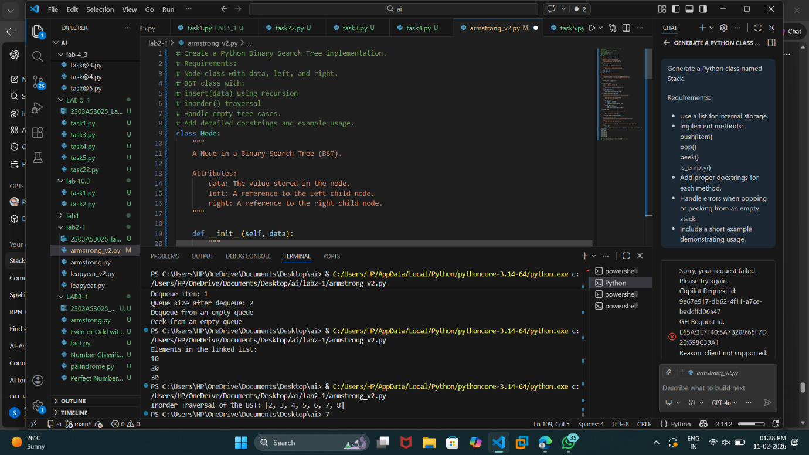

**Task Description #5 – Hash Table**

Task: Use AI to implement a hash table with basic insert, search, and

delete methods.

Sample Input Code:

class HashTable:

pass

Expected Output:

• Collision handling using chaining, with well-commented methods.

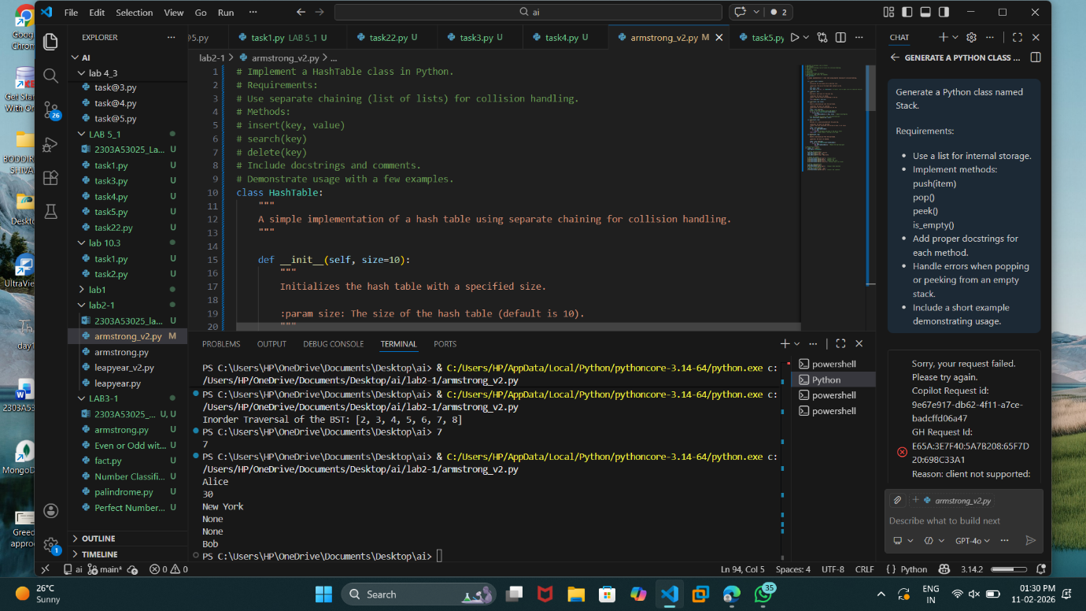

**Task Description #6 – Graph Representation**

Task: Use AI to implement a graph using an adjacency list.

Sample Input Code:

class Graph:

pass

Expected Output:

• Graph with methods to add vertices, add edges, and display

connections.

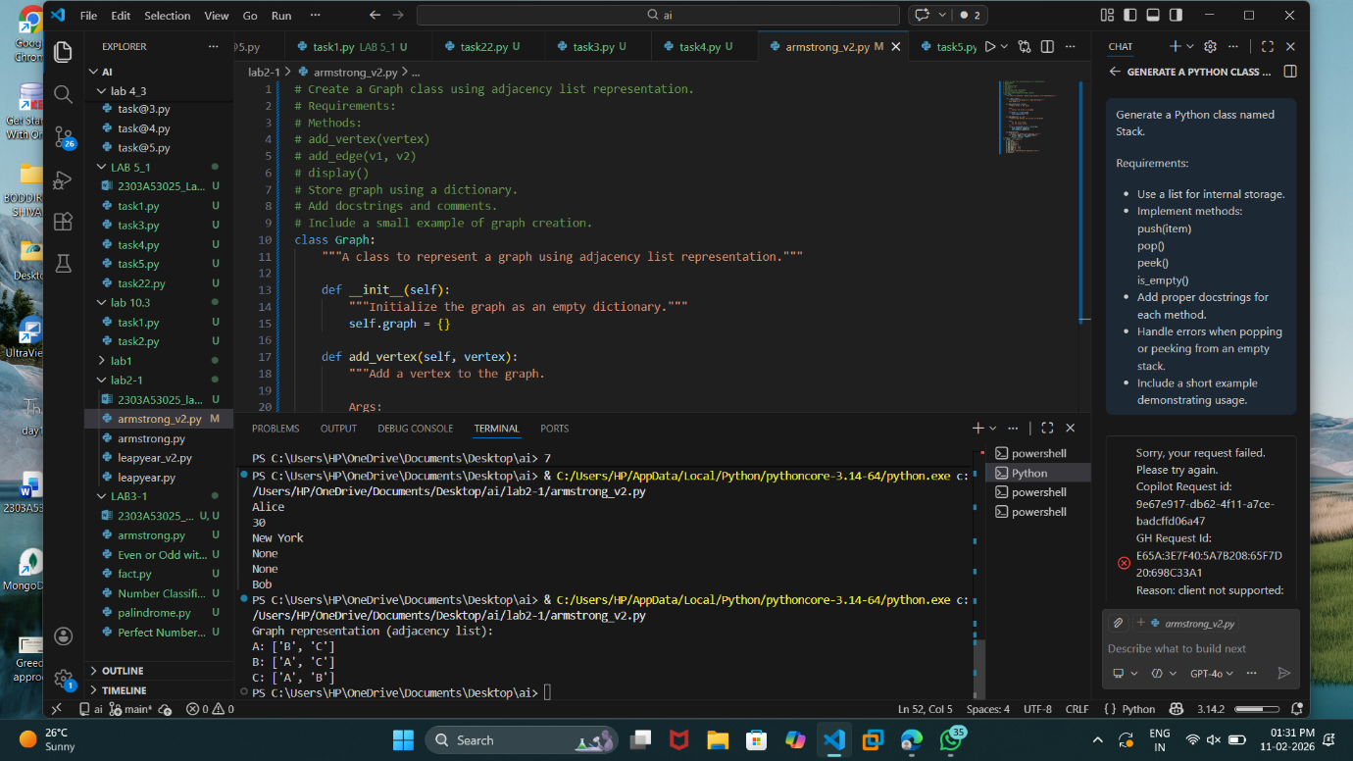

**Task Description #7 – Priority Queue**

Task: Use AI to implement a priority queue using Python’s heapq

module.

Sample Input Code:

class PriorityQueue:

pass

Expected Output:

• Implementation with enqueue (priority), dequeue (highest priority),

and display methods.

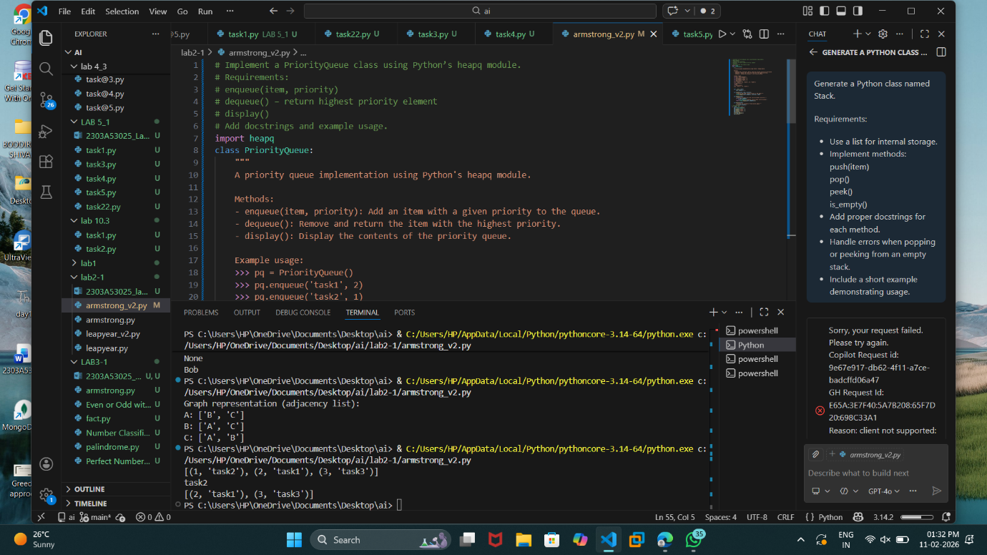

**Task Description #8 – Deque**

Task: Use AI to implement a double-ended queue using

collections.deque.

Sample Input Code:

class DequeDS:

pass

Expected Output:

• Insert and remove from both ends with docstrings.

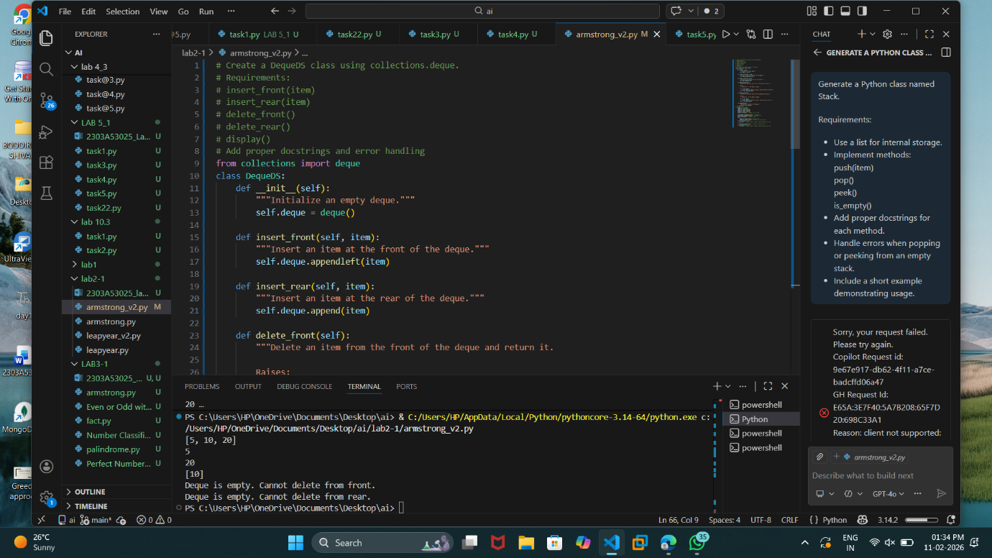

**Task Description #9 Real-Time Application Challenge – Choose the**

**Right Data Structure**

Scenario:

Your college wants to develop a Campus Resource Management System

that handles:

1. Student Attendance Tracking – Daily log of students

entering/exiting the campus.

2. Event Registration System – Manage participants in events with

quick search and removal.

3. Library Book Borrowing – Keep track of available books and their

due dates.

4. Bus Scheduling System – Maintain bus routes and stop

connections.

5. Cafeteria Order Queue – Serve students in the order they arrive.

Student Task:

• For each feature, select the most appropriate data structure from

the list below:

o Stack

o Queue

o Priority Queue

o Linked List

o Binary Search Tree (BST)

o Graph

o Hash Table

o Deque

• Justify your choice in 2–3 sentences per feature.

• Implement one selected feature as a working Python program with

AI-assisted code generation.

Expected Output:

• A table mapping feature → chosen data structure → justification.

• A functional Python program implementing the chosen feature

with comments and docstrings.

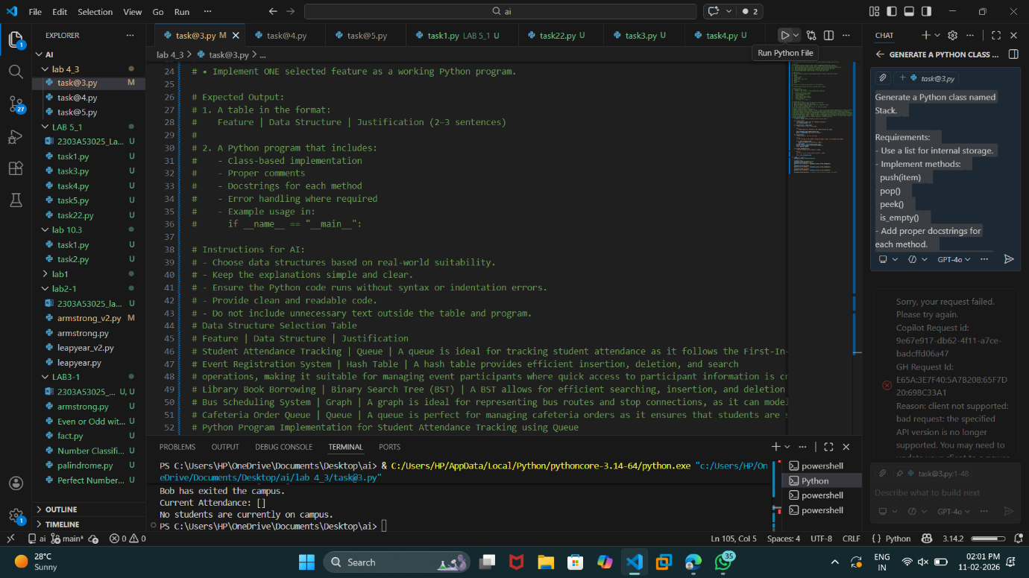

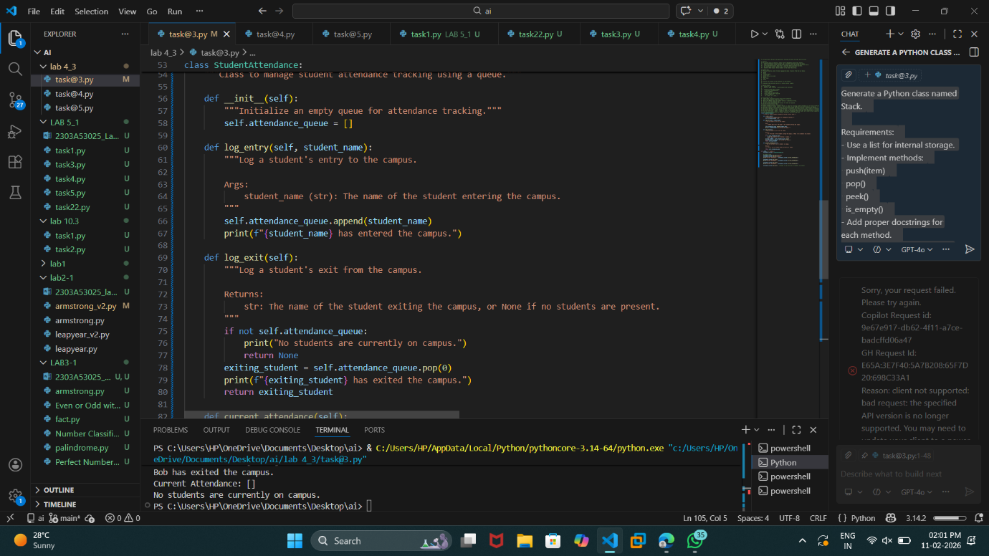

**Task Description #10: Smart E-Commerce Platform – Data Structure**

**Challenge**

An e-commerce company wants to build a Smart Online Shopping System

with:

1. Shopping Cart Management – Add and remove products

dynamically.

2. Order Processing System – Orders processed in the order they are

placed.

3. Top-Selling Products Tracker – Products ranked by sales count.

4. Product Search Engine – Fast lookup of products using product ID.

5. Delivery Route Planning – Connect warehouses and delivery

locations.

Student Task:

• For each feature, select the most appropriate data structure from

the list below:

o Stack

o Queue

o Priority Queue

o Linked List

o Binary Search Tree (BST)

o Graph

o Hash Table

o Deque

• Justify your choice in 2–3 sentences per feature.

• Implement one selected feature as a working Python program with

AI-assisted code generation.

Expected Output:

• A table mapping feature → chosen data structure → justification.

• A functional Python program implementing the chosen feature

with comments and docstrings.

